Project Planning Phase
Project Planning Template (Product Backlog, Sprint Planning, Stories, Story points)

Date | 30 September 2026
Team ID | SN-TRANSFORM-01
Project Name | Import Data using Transform Maps (Spreadsheet)
Maximum Marks | 5 Marks

Product Backlog, Sprint Schedule, and Estimation (4 Marks)
The backlog below converts the approved ServiceNow employee-import requirements into two focused implementation sprints.
Sprint | Functional Requirement (Epic) | User Story Number | User Story / Task | Story Points | Priority | Team Members
Sprint-1 | Data Intake & Target Design | USN-1 | As an administrator, I can verify the employee spreadsheet headers and sample rows before loading data. | 2 | High | Project Team
Sprint-1 | Data Intake & Target Design | USN-2 | As an administrator, I can load the spreadsheet into the Employee Import staging table. | 3 | High | Project Team
Sprint-1 | Data Intake & Target Design | USN-3 | As an administrator, I can create Employee Test with Employee ID, Name, Email, Department and Location fields. | 3 | High | Project Team
Sprint-1 | Data Intake & Target Design | USN-4 | As an administrator, I can create the Sample Spreadsheet Import Transform Map and review field mappings. | 3 | High | Project Team
Sprint-2 | Transform, Validation & Reporting | USN-5 | As an administrator, I can coalesce on Employee ID so repeat imports update existing records and insert new records. | 5 | High | Project Team
Sprint-2 | Transform, Validation & Reporting | USN-6 | As a data owner, I can review Transform History and validate imported employee values. | 2 | High | Project Team
Sprint-2 | Transform, Validation & Reporting | USN-7 | As an HR/data owner, I can view department, location and employee-list reports. | 2 | Medium | Project Team
Sprint-2 | Transform, Validation & Reporting | USN-8 | As a stakeholder, I can view the Employee Analytics Dashboard for import outcomes. | 3 | Medium | Project Team

Project Tracker, Velocity & Burndown Chart: (4 Marks)
Sprint | Total Story Points | Duration | Sprint Start Date | Sprint End Date (Planned) | Story Points Completed (as on Planned End Date) | Sprint Release Date (Actual)
Sprint-1 | 11 | 5 Days | 30 Sep 2026 | 04 Oct 2026 | TBD | TBD
Sprint-2 | 12 | 5 Days | 05 Oct 2026 | 09 Oct 2026 | TBD | TBD

Velocity:
The planned velocity is calculated from the total backlog estimate divided by the two planned sprints. Story points are estimates, not hours.
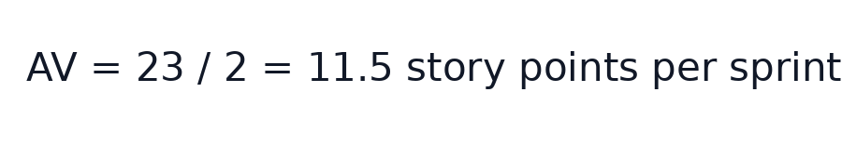

Burndown Chart:
The planned burndown shows 23 estimated story points reducing to zero across the two five-day sprints. Actual completion is updated during sprint reviews.
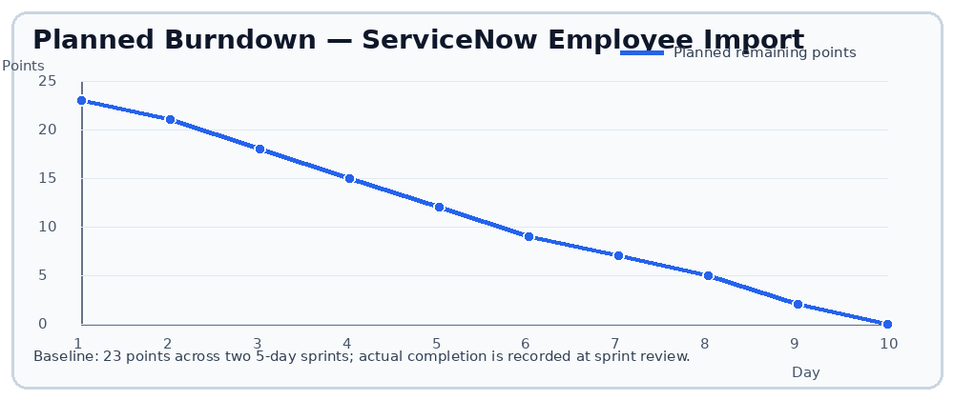
References:
Phase-II User Stories — Employee Spreadsheet Import
Phase-II Solution Requirements — Transform Maps
Solution Architecture — ServiceNow Employee Import

